Facility: Buildings of nuclear industry
A finite element model was created in the Sofistik software package for structural calculations of the building. The model is shown in Figure 1.
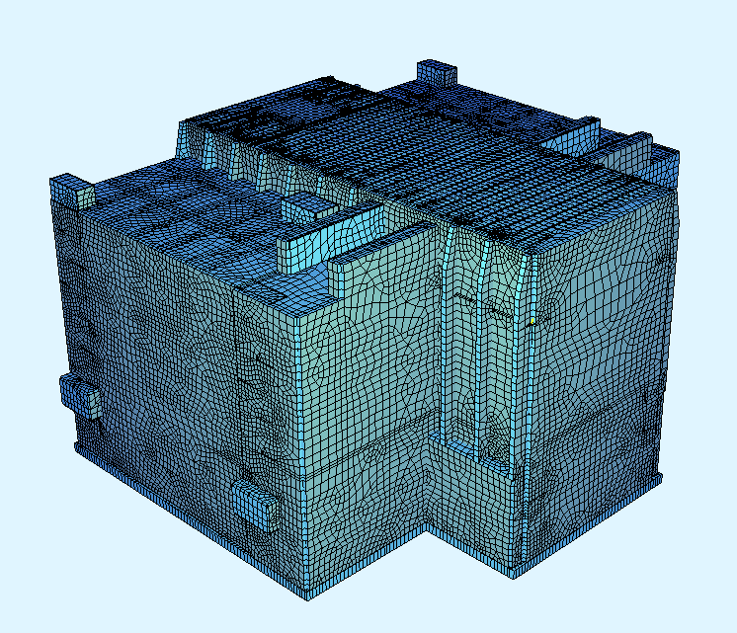
Figure 1 - Design model of a small reactor building
The design model is made with the help of the following finite elements for modeling building structures:
containments - foundation slabs, flooring, roofs, walls;
bars- floor beams and roofs, columns;
The overall dimensions of the building are 74.4 x 66.65 m. The maximum height is 44.7 m. The span of the roof girders is 27.4 m. The distance along the axes of the girders is 1.8 m. The height of the girder is 1.5 m, the thickness of the roof slab is 0.4 m.
Girders are reinforced with tendons (3 tendons of 13 strands each), tensile strength of 1860 MPa with post-tensioning.
A certified Russian prestressing system with bonding and post-tensioning by STS Ltd. (Moscow) is applied.
The calculations resulted in the values ​​of the natural vibration frequencies. The first three frequencies are respectively equal:
The first form of natural vibration is shown in Figure 2.
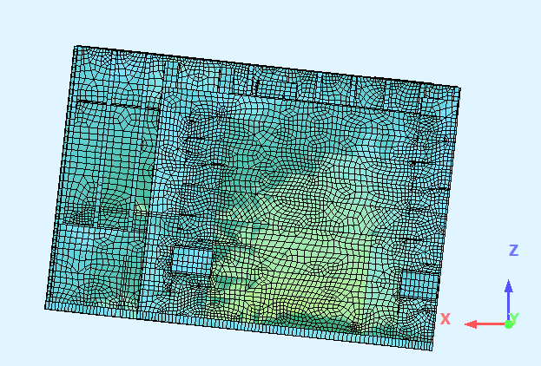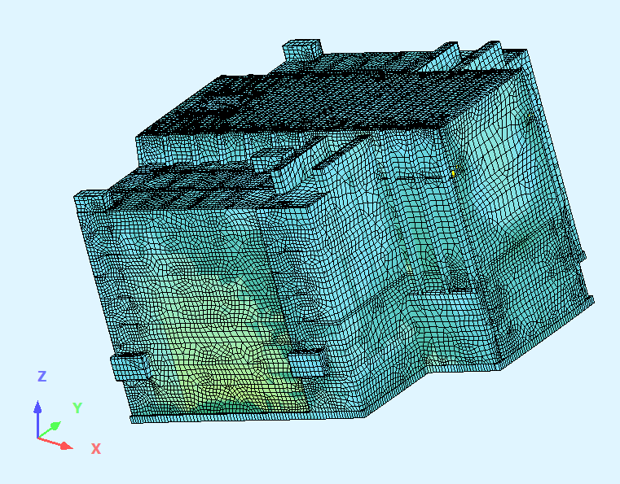
Figure 2 - First form of natural vibration
Structural analysis was done with regard to the normal operation loads and one of the special effects (aircraft crash). The design values ​​of the normal operation loads are adopted in accordance with SP 20.13330.2016 “Loads and impacts”.
A special combination (load from aircraft crash) in calculating the coverage has become decisive. The necessary initial parameters for load modeling in case of airplane crash were taken from the book “Extreme Impacts on Structures” by A. N. Birbraer.
An aircraft with maximum take-off mass of 5670 kg and speed of 100 m/s was adopted as the design load. The area of ​​the impact spot S = 12 m^{2.} The direction of impact is taken at an angle of 45 degrees to the horizontal line, according to PiN AE 5.6. Accounting for the crash of this Lear Jet-23 aircraft is provided for by French standards and IAEA recommendations. It carries 5-7 passengers, two crew members.
The time schedule of the load on building structures is shown in Figure 3.
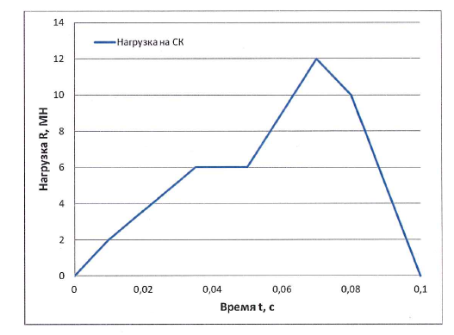
Load on structure
Time t, s
Load R, MN
Figure 3 - Load upon impact of aircraft of 5670 kg at speed of 100 m/s
When simulating the impact force, a quasistatic calculation method was used applying a dynamic factor. Its diagram is shown in Figure 4.
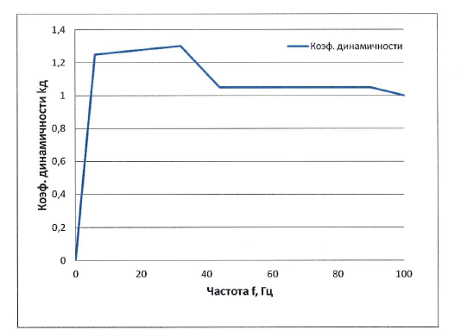
Dynamic factor
Frequency f, Hz
Dynamic factor, kd
Figure 4 - Dynamic factor
Also, direct dynamic calculation was used to compare efforts. The function shown in Figure 3 was applied for this calculation.
Efforts for calculations are based on the worst of the two calculation options above.
The cross sections of the girders and the flooring slabs for the efforts from an airplane crash were checked according to I of State Fire-fighting Service excluding the dynamic hardening factor of concrete and reinforcement overstretching.
The calculation according to II of State Fire-fighting Service for efforts from a special combination wasn’t done, since according to SP 63.13330.2012, cracks growth and vertical deflections are calculated only in case of influence of normative permanent and temporary (long-term or short-term) loads.
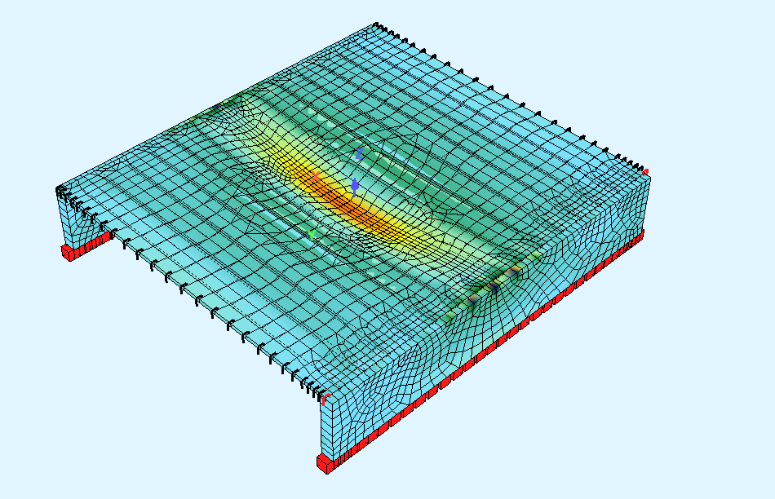
Figure 5 - Fragment of the design model with regard to load effects from aircraft crash
Table 1 shows the consumption of materials per 1 m² of building roof.

Table 1 - Consumption of materials per 1 m² of roof.
Indicator | Value
Consumption of cast-in-place concrete B30 | 0.7 m³/m²
Reinforcement А500 С | 177 kg/m²
Strands К-7 Ø15,7 mm 1860 mPa without sheathe | 27 kg/m² *
Anchor AKS-13 | 0.12 pcs/m²
Steel duct D_{int}=90 mm | 1.62 m/m²
* with regard to off-gauge of coils

