Facility: Parking floors
The preliminary project considers parking flooring with a uniform grid of columns 12x12 m and 12x18 m. The parking building consists of two parts of 142.3x66 m and 118.25x66 m in the plan view. The total number of parking lots is 293 including car lots - 58, truck lots - 166; special vehicle lots - 69.
Description of flooring variant
Flooring has girders in two directions. The main girders are located along the alphabetic axes in increments of 12 and 18 m. The secondary girders are located along the digital in increments of 4 m. The floor thickness is 220 mm. Concrete of floors is B35. Girders are reinforced with tendons (13 strands per tendon) with a diameter of 15.7 mm, tensile strength of 1860 MPa. A certified Russian pre-stressing system with bonding and post-tensioning by STS Ltd. (Moscow) is used. Roof of the building is inaccessible.
Types of the main girders of the floors at elevation +0,000 and +6,900:
Type 1 - girders along axes В and Г of section 400х1400;
Type 2 - girders along axes Б and Д of section 400х1100;
Type 3 - girders along axes A and Е of section 400х1000.
Types of the main girders at elevation +13,800:
Type 4 - girders along axes Б, В, Г, Д of section 400х1000;
Type 5 - girders along axes A and Е of section 400х1000.
Types of the secondary girders:
Type 6 - girders along digital axes at elevation +0,000 and +6,900 of section 400х1000;
Type 7 - girders along digital axes at elevation +13,800 of section 400х900.
Height of the girders is given with regard to the floor thickness.
The design load on the floor
- Dead weight of cast-in-place reinforced concrete (γ_{f} = 1.1);
- Permanent load of floor covering 204 kg/m2 (γ_{f} = 1.3);
- Permanent load of floor “pie” 400 kg/m2 (γ_{f} = 1.3);
- Temporary vertical load of trucks is considered as the load on public loads A14 as per SP 35.13330.2011 “Bridges and pipes”. Factors of safety and dynamic factors for load of anchors AK are given in Table 1
- Snow load on the roof 153 kg/m2 (γ_{f} = 1.4, duration factor 0,5)

Table 1 - Factors of safety and dynamic factors for load of anchors AK
Pat of AK load | γ_{f} | (1+µ)
Distributed v | 1.15 | 1.0
Four-wheel bogie 2P | 1.5 | 1.3

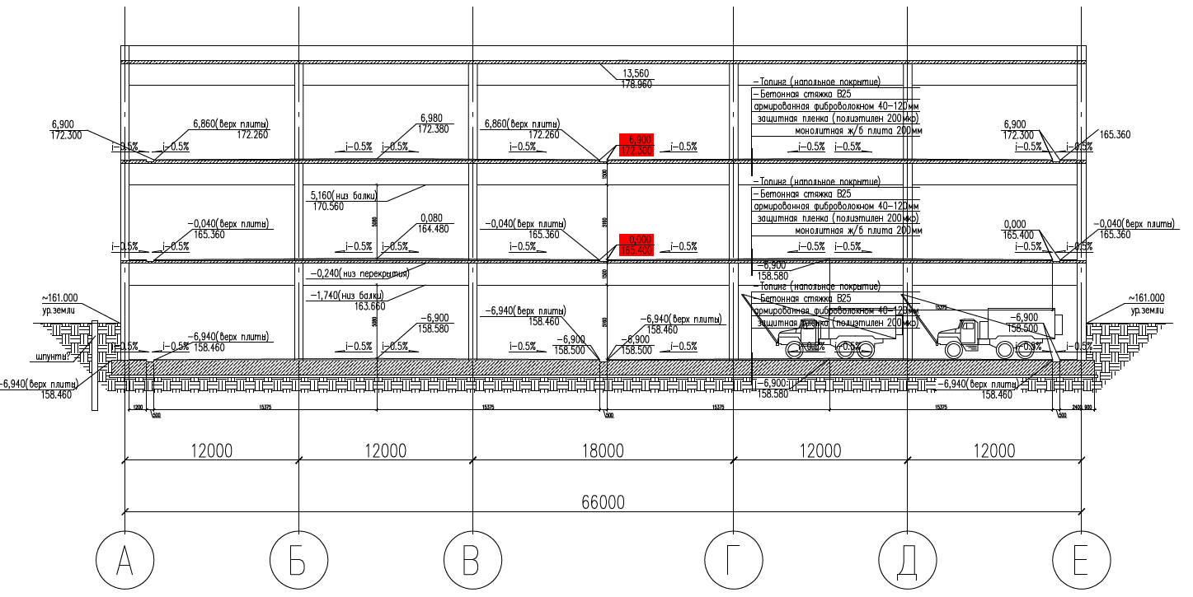
Fig. 1. Extract of sectional view of a building
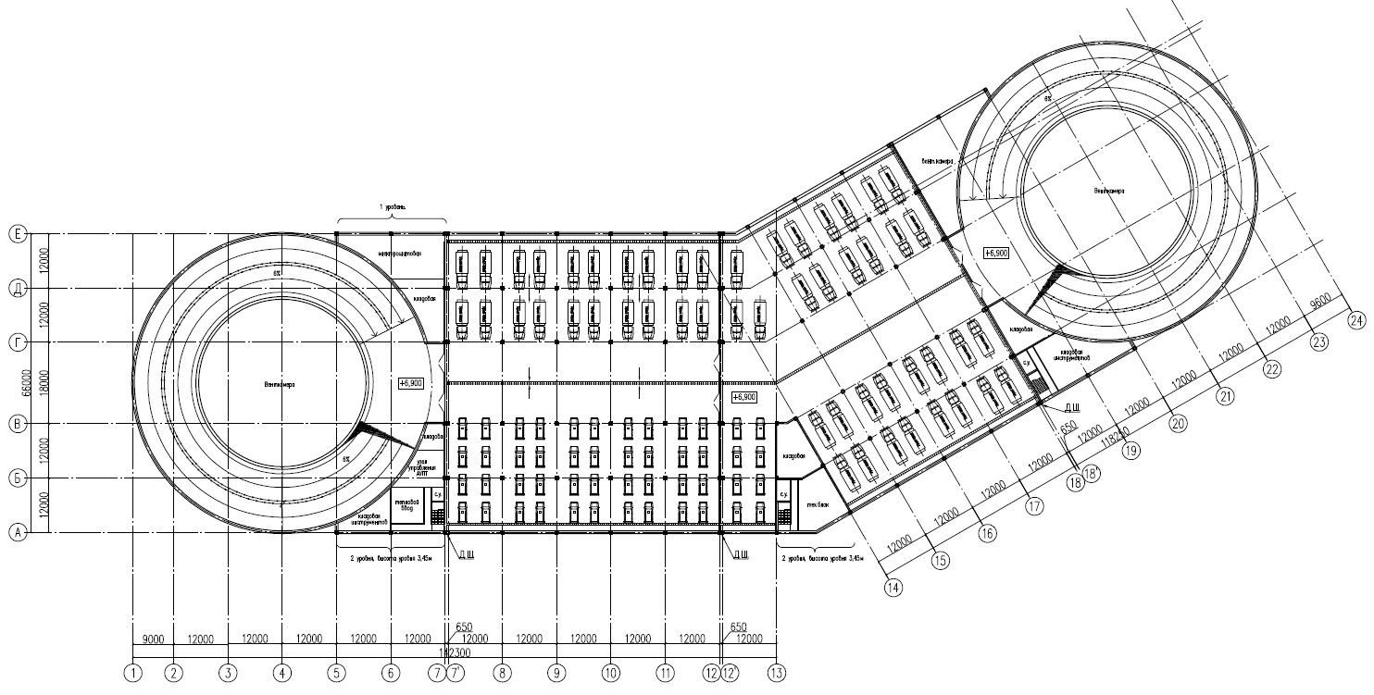
Fig. 2. Plan of a normal floor
Consumption of materials per 1 m² are given in Table 2.
Table 2 - Consumption of materials per 1 m² of floor
Expendable indicator | Indicator value
Cast-in-place concrete B35 | 0,33 m³/m²
Reinforcement А500 С | 42,49 kg/m²
Strands К-7 Ø15,7 mm 1860 mPa without sheathe | 11,17 kg/m² *
Anchors AKS-13 | 0,022 pcs/m²
Steel duct D_{int}=85 mm | 0,72 m/m²
* with regard to off-gauge of coils

