Certificate SRO №0583.00-2017-7724406086-П-077



|  |  |  |
| --- | --- | --- |
| INSTITUTE OF PRESTRESSING TECHNOLOGIES | JSC IPT | 117405, Moscow,  ul. Kirpichniye vyemki, 2,  bld. 1  +7 (495) 120-21-81  [info@tension.ru](mailto:info@tension.ru)  [www.tension.ru](http://www.tension.ru) |

**Superstructure of metro bridge overpass**

**PRELIMINARY PROJECT**

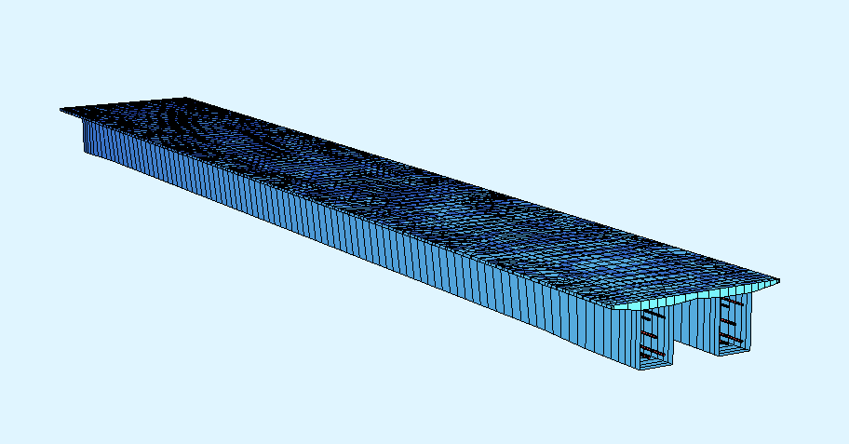

**П22-РР**

**2019**

**General data**

The preliminary project considers two variants of monolithic superstructure of the metro bridge at the section from station “________” to station "__________". The superstructure is simple. Its overall length is 42 m and consists of two girders joined over the slab of the ballast pocket. The design span is 41.1 m. The general view of the design model is shown in Figure 1.

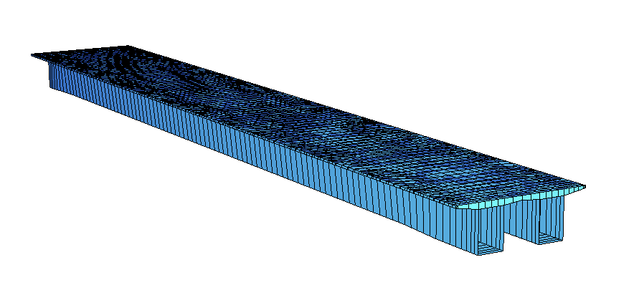

Figure 1 - General view of the design model

**The following basic loads were used for calculation**

- The dead weight of cast-in-place reinforced concrete is automatically recognized (γf = 1,1);

- second part of the constant load 30 kN/m (γf = 1,3);

- load from the base 4 kN/m (γf = 1,1);

- load from the canopy shown in Figure 2 (γf = 1,4);

- load from the centrifugal force is 11.2 kN/m (γf = 1,2);

- load from wind 6,5 kN/m (γf = 1,4).

- temporary vertical load from the rolling stock of the mass rapid transit as a train of the design length, consisting of four-axle cars (147 kN per axle), (γf = 1,246; 1+µ=1,16)/

The temporary vertical load is increased by 2.5% to account for possible eccentricity of the track axis relative to the superstructure axis and overload of one of the girders.

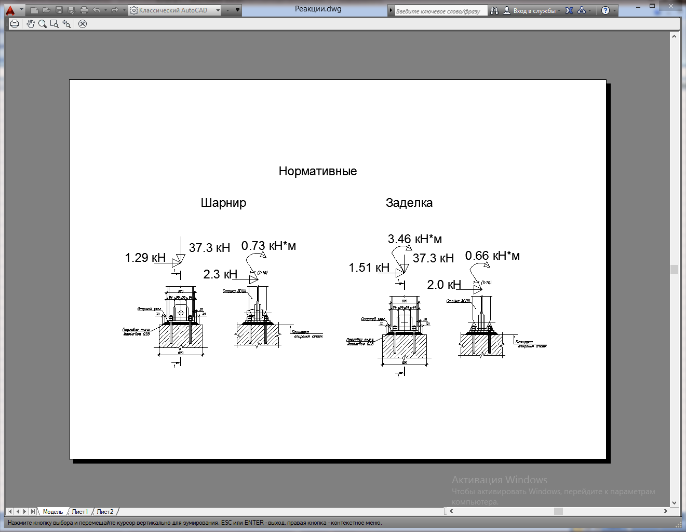

Embedding

Hinge

Figure 2 - Basic loads from the canopy

The superstructure girders are tested for strength and crack resistance at the tension and operation stages, as well as for deformations. The calculations accounted for the effects of creep and shrinkage of concrete.

**Description of the 1st version of superstructure**

The first version of the superstructure is made in the geometry given in the original version.  
 The cross section is shown in Figure 3.

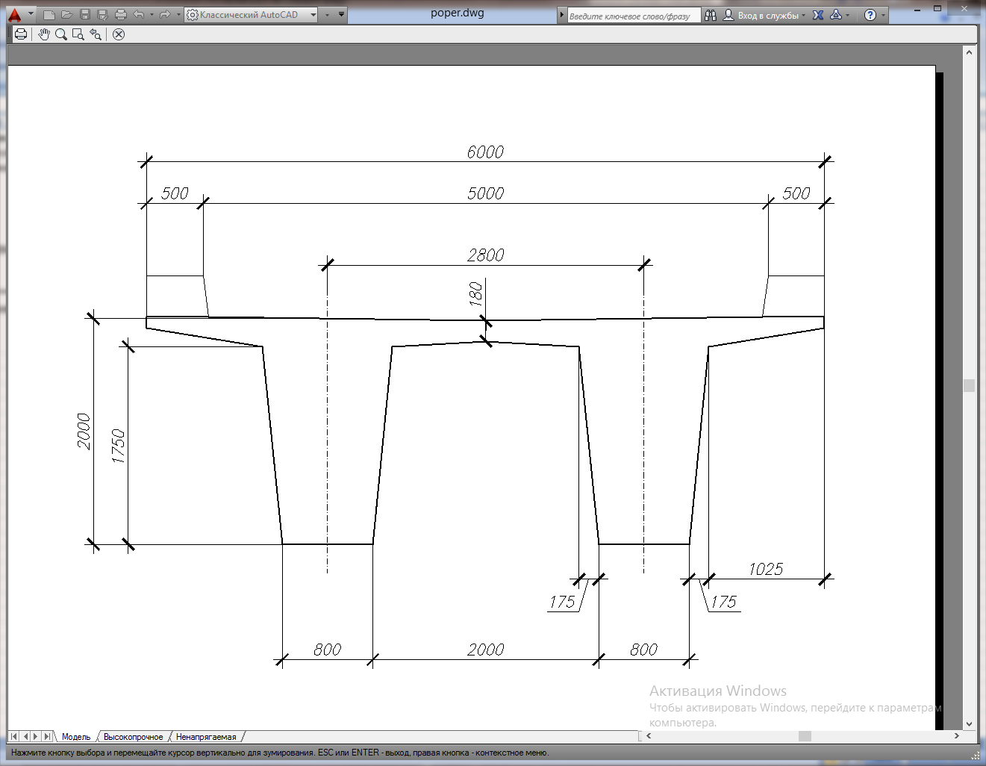

Figure 3 - Cross section of superstructure - first version

Material of the structure: concrete B55, non-prestressed reinforcement of classes A400.

Girders are reinforced with tendons (13 strands per tendon) with a diameter of 15.7 mm, tensile strength of 1860 MPa (under GOST R 53772-2010). A certified Russian prestressing system with bonding and post-tensioning by STS Ltd. (Moscow) is applied. Arrangement of tendons in the model is shown in Figure 4.

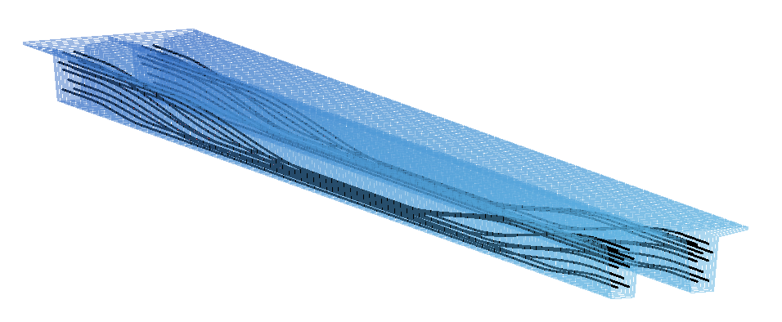

Figure 4 - Arrangement of tendons in the model

The diagrams of strain and stress obtained during calculation of the first variant are given in Appendix 1.

Table 1 shows consumption of materials per 1 running meter of the superstructure, the volumes of concrete and the weight of prestressed reinforcement.

Table 1 - Consumption of materials for superstructure of first variant

|  |  |  |
| --- | --- | --- |
| Indicator | Consumption per 1 running meter of superstructure | Volume for the whole superstructure |
| Cast-in-place concrete B55 | 4.68 m3/m | 196.86 m3 |
| Strands К-7 Ø15,7 mm 1860 mPa without sheathe | 325,6 kg/m * | 13,68* t |
| Anchor AKS-13 | 0.95 pcs/running meter | 40 pcs. |
| Steel duct Dint=90 mm | 20,47** m/running meter | 860** m |

* with regard to off-gauge of coils (+3%) and process “tails”;

** (+2%) for the length of ducts.

Consumption of cast-in-place concrete is given excluding the sides of the ballast pocket trim.

**Description of the 2nd version of superstructure**

The second version suggests a different geometry the end sections of the girders. This is done for optimal location of anchors. Figure 5 shows the sections of the superstructure on the bearing and in the span, taking into account location of anchors and ducts. The broader rib in the bearing zone is 2.625 m long. The transition area from the bearing section to the span section has the same length.

*Section of the span*

*Section of the bearing*

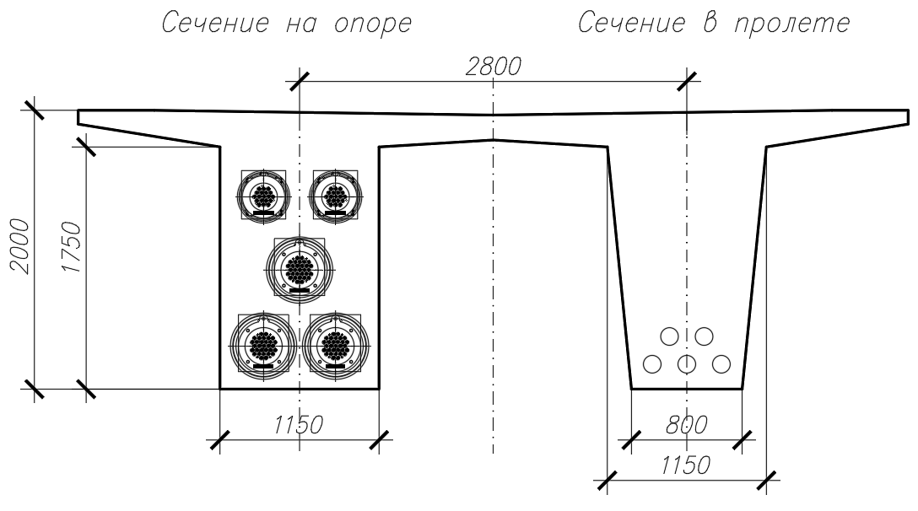

Figure 5 - Cross sections of superstructure in second variant

Material of the structure: concrete B55, non-prestressed reinforcement of classes A400.

Girders are reinforced with tendons (31 and 19 strands per tendon) with a diameter of 15.7 mm, tensile strength of 1860 MPa (under GOST R 53772-2010). A certified Russian prestressing system with bonding and post-tensioning manufactured by STS Ltd. (Moscow). Arrangement of tendons in the model is shown in Figure 6.

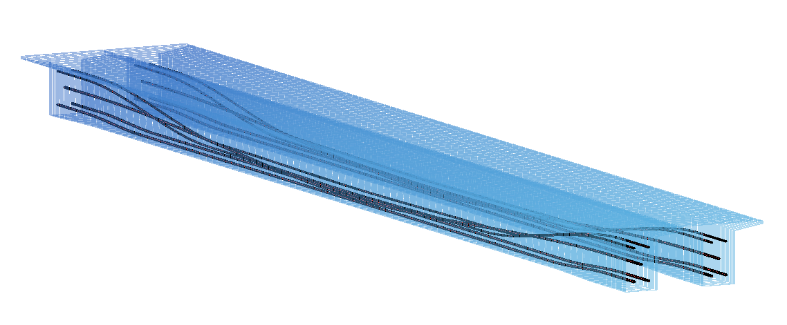

The diagrams of strain and stress obtained during calculation of the second variant are given in Appendix 1.

Table 2 shows consumption of materials per 1 running meter of the superstructure, the volumes of concrete and the weight of prestressed reinforcement.

Table 2 - Consumption of materials for superstructure of second variant

|  |  |  |
| --- | --- | --- |
| Indicator | Consumption per 1 running meter of superstructure | Volume for the whole superstructure |
| Cast-in-place concrete B55 | 4.8 m3/m | 201,7 m3 |
| Strands К-7 Ø15,7 mm 1860 mPa without sheathe | 327,6 kg/m * | 13,76* t |
| Anchor AKS-31 | 0.285 pcs/m | 12 pcs. |
| Anchor AKS-19 | 0.19 pcs/m | 8 pcs. |
| Steel duct Dint= 120 mm | 6,12** m/running meter | 257** m |
| Steel duct Dint= 100 mm | 4,1** m/running meter | 171.4** m |

* with regard to off-gauge of coils (+3%) and process “tails”;

** (+2%) for the length of ducts.

Consumption of cast-in-place concrete is given excluding the sides of the ballast pocket trim.