Certificate SRO №0583.00-2017-7724406086-П-077



|  |  |  |
| --- | --- | --- |
| INSTITUTE OF PRESTRESSING TECHNOLOGIES | JSC IPT | 117405, Moscow,  ul. Kirpichniye vyemki, 2,  bld. 1  +7 (495) 120-21-81  <info@tension.ru>  [www.tension.ru](http://www.tension.ru) |

**Preliminary project**

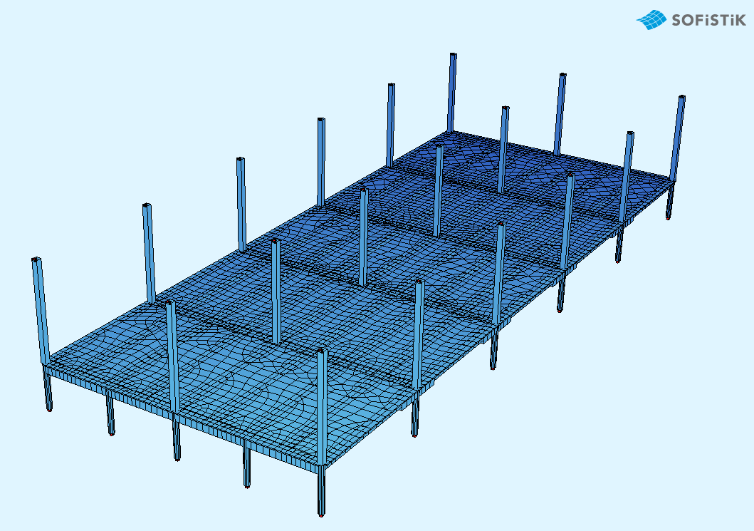

**Prestressed girders as part of floor slabs**

**General**

The preliminary project considers the monolithic flooring of the shopping complex. The flooring is rectangular in the plan view. The overall dimensions of the specified flooring area are 32x16 m along the axes.

The flooring is based on reinforced concrete columns with cross-section of D600 mm. Thickness of the floor slab is 120 mm. Span of the slab of 3,5 m in the clear. Due to the accepted arrangement of the girders, the floor slab mainly works in one direction.  
 The connection of the columns and prestressed girders is rigid.

Static calculation with regard to the stages of the flooring construction and application of loads was performed in the certified design complex SOFiSTiK 2020. Prestress losses are determined automatically in the software package. The calculation takes into account the creep and shrinkage of the structure concrete structure, as well as the resulting loss of prestress. Reinforced concrete elements are checked in accordance with sections 8 and 9 of SP 63.13330.2012.

Materials:

- flooring concrete B30. The transfer strength of concrete corresponds to the compressive strength class B25;

- prestressed reinforcement is made as tendons (7 and 13 strands per tendon) of K7-15,7-1860 of strands according to GOST R 53772-2010. Corrugated steel ducts are used to shape tendons. Controlled tension force is 1320 MPa;

- non-prestressed reinforcement of the girders is reinforcement A500 and A240.

The design provides two types of prestressed girders in the flooring:

- longitudinal girders along the digital axes with a span of 16 m and height 1000/700 or 1100/700 mm (height is given for the bearing and span sections, respectively);

- transverse girders along the alphabetical axes with a span of 8 m and height of 1100 mm;

The design load on the floor:

- The dead weight of cast-in-place reinforced concrete is automatically recognized (γf = 1,1);

- Permanent load from floors 180 kg/m2 (γf = 1,3);

- Long-term load from utility systems and partitions 200 kg/m2 (γf = 1.3);

- Short-term load 500 kg/m2 (γf = 1.2, duration factor 0.35);

A certified Russian pre-stressing system with bonding and post-tensioning by STS Ltd. (Moscow, Russia) is used. The girders are tensioned with a hydraulic jack ДН-13 by STS Ltd. Edge and center distances of the sleeve-type anchors are adopted according to STO standard of STS.

The layout plan of the girders of the considered flooring area is shown in Figure 1.

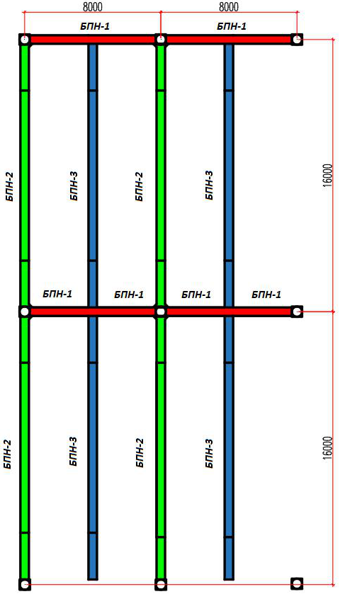

**BPN-3**

**BPN-3**

**BPN-3**

**BPN-3**

**BPN-2**

**BPN-2**

**BPN-2**

**BPN-2**

**BPN-1**

**BPN-1**

**BPN-1**

**BPN-1**

**BPN-1**

**BPN-1**

Figure 1 - Layout plan of prestressed floor girders

**Description of design solutions**

**BPN-1** (shown in red in Figure 1) is a prestressed girder of cross-section 500x1100 (h). The girder designed along alphabetical axes. It has a span of 8 m along the axes. This girder is reinforced with 2 tendons of 7 strands K7-15,7-1860. The cross-section of BPN-1 girder for the span and bearing sections is shown in Figure 2. The height of the girder is given with regard to the thickness of the floor t = 120 mm.

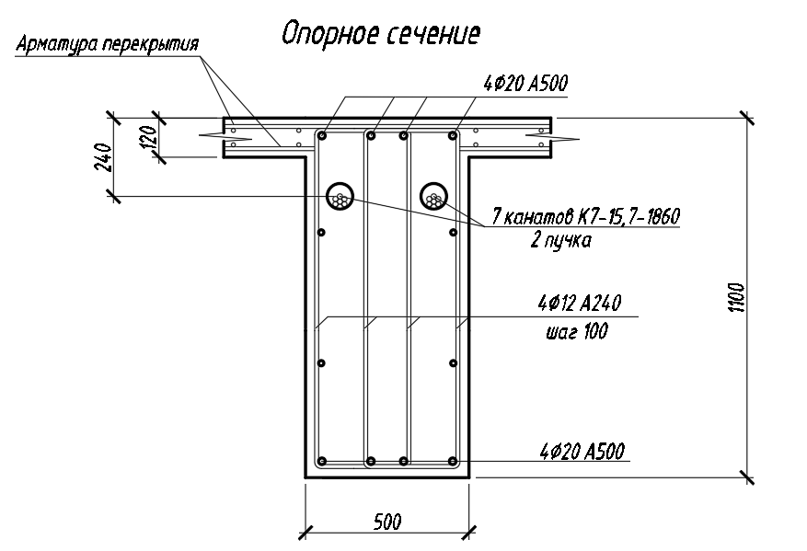

***increment 100***

***7 strands K7-15,7-1860***

***2 tendons***

***Bearing section***

***Flooring reinforcement***

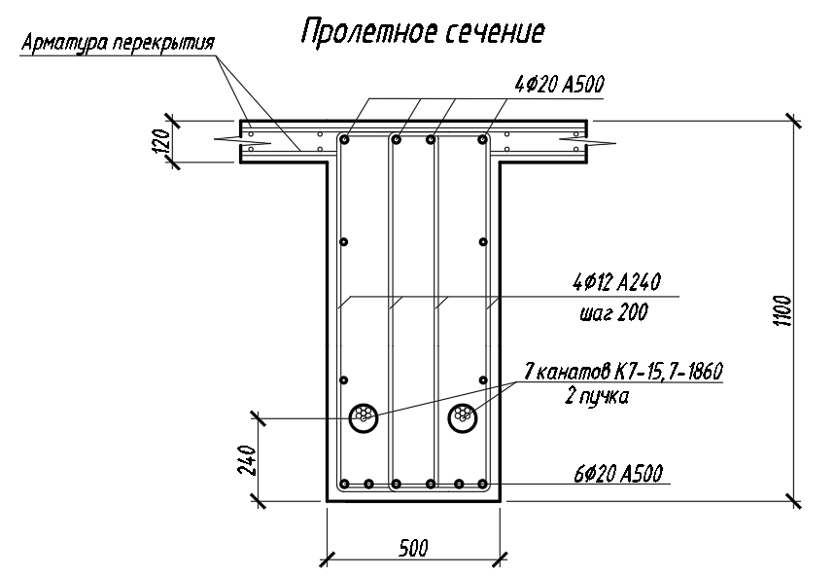

***7 strands K7-15,7-1860***

***2 tendons***

***increment 200***

***Span section***

***Flooring reinforcement***

Figure 2 - Cross-sections of girder BPN-1

**BPN-2** (shown in green in Figure 1) is a prestressed girder of cross-section 500x1100 (h) in the bearing section and 500x700 (h) in the span section. The girder designed along digital axes. It has a span of 16 m along the axes and bears on the monolithic columns. This girder is reinforced with 1 tendon of 13 strands K7-15,7-1860. The cross-section of BPN-2 girder for the span and bearing sections is shown in Figure 3. The height of the girder is given with regard to the thickness of the floor t = 120 mm.

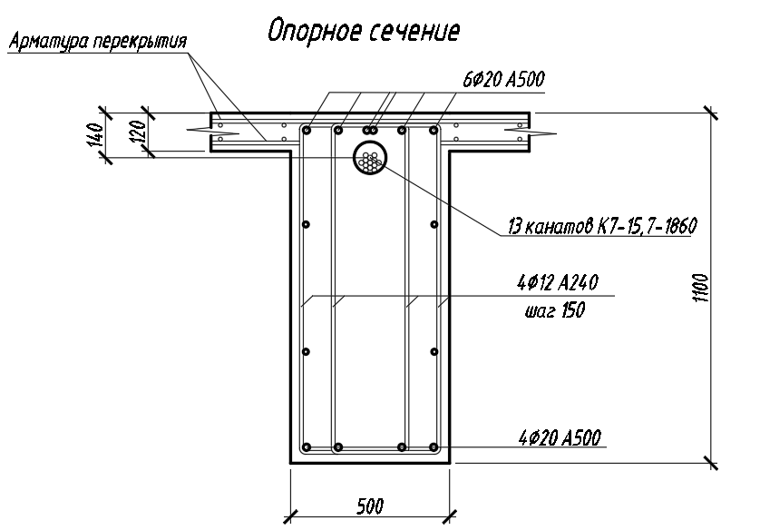

***13 strands K7-15,7-1860***

***increment 150***

***Bearing section***

***Flooring reinforcement***

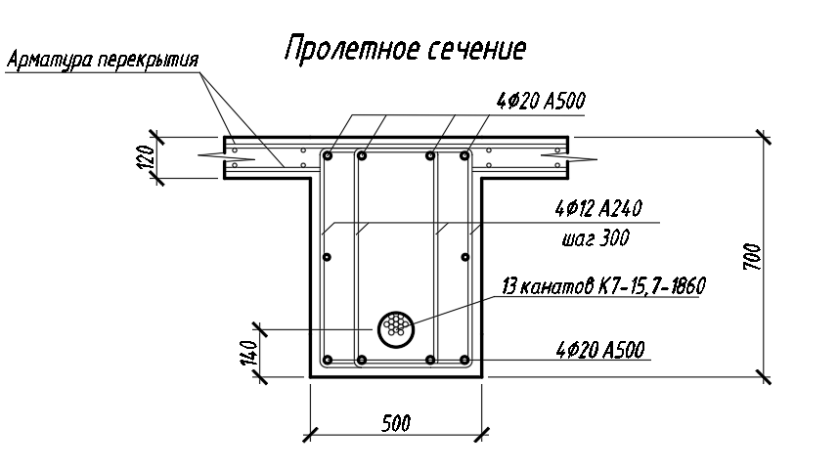

***increment 300***

***13 strands K7-15,7-1860***

***Span section***

***Flooring reinforcement***

Figure 3 - Cross-sections of girder BPN-2

**BPN-3** (shown in blue in Figure 1) is a prestressed girder of cross-section 500x1000 (h) in the bearing section and 500x700 (h) in the span section. The girder designed along digital axes. It has a span of 16 m along the axes and bears on the transverse prestressed girders BPN-1. This girder is reinforced with 1 tendon of 13 strands K7-15,7-1860. The cross-section of BPN-3 girder for the span and bearing sections is shown in Figure 4. The height of the girder is given with regard to the thickness of the floor t = 120 mm.

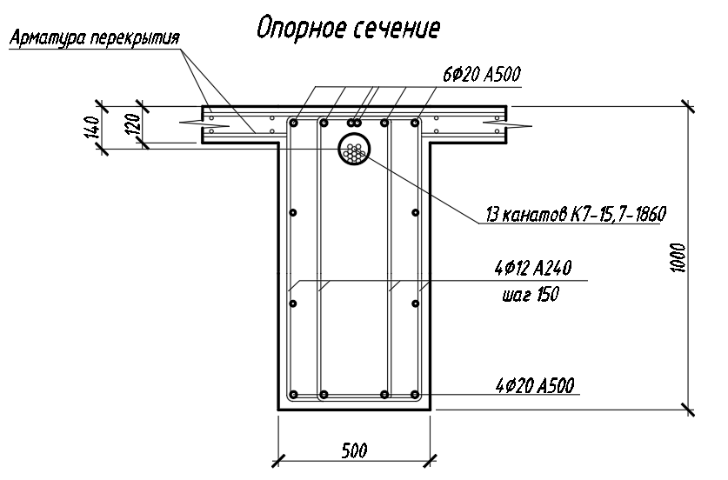

***13 strands K7-15,7-1860***

***increment 150***

***Bearing section***

***Flooring reinforcement***

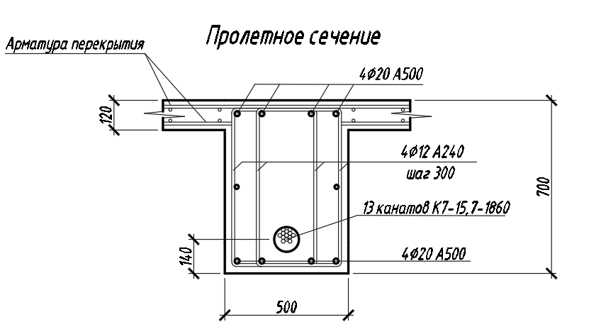

***Span section***

***13 strands K7-15,7-1860***

***increment 300***

***Flooring reinforcement***

Figure 4 - Cross-sections of girder BPN-3

Consumption of flooring materials are given in Table 1. Consumption is calculated for a 32x16 m flooring area, as well as for 1 m2. Consumption of non-prestressed reinforcement is given excluding floor slab reinforcement. Since consumption of the prestressing system elements are affected by the total size of the flooring and the size of the bays for concreting, the volumes of anchors and butt anchors are calculated based on the dimensions of the flooring 62.9x79.3 m (this area is divided into 4 concreting bays).

Table 1 - Consumption of materials per 512 m2 and 1 m2

|  |  |  |
| --- | --- | --- |
| Expendable indicator | The value of the indicator per 1 m2 | The value of the indicator per 512 m2 |
| **Concrete B30** | | |
| Floor slab | - | 61,44 m3 |
| Girders (without regard to the slab) | - | 61,20 m3 |
| Total of concrete B30 | 0.240 m3/m2 | 122.64 m3 |
| **Prestressing system** | | |
| Strands К-7 Ø15,7 mm 1860 mPa without sheathe | 5,031 * kg/m2 | 2275,8 kg * |
| Anchor AKS-13 (STS Ltd.) | 0.00625 pcs/m2 | 3.2 pcs. |
| Anchor AKS-7 (STS Ltd.) | 0.00394 pcs/m2 | 2.016 pcs. |
| Joint SK-13 (STS Ltd.) | 0.00313 pcs/m2 | 1.6 pcs. |
| Joint SK-7 (STS Ltd.) | 0.00197 pcs/m2 | 1.008 pcs. |
| Steel duct Dint=90 mm (under 13-strand tendon) | 0.2550 m/**m2 | 130.56** m |
| Steel duct Dint= 70 mm (under 7-strand tendon) | 0.1275 m/**m2 | 65.28** m |
| **Non-prestressed reinforcement** | | |
| Longitudinal reinforcement of girders A500 | - | 4441 kg |
| Transverse reinforcement of girders A240 | - | 4597 kg |
| Total of girder reinforcement | 17,6 kg/m2 | 9007 kg |

* with regard to off-gauge of coils (+3%)

** with regard to+2% for the length of ducts

**Appendix A**

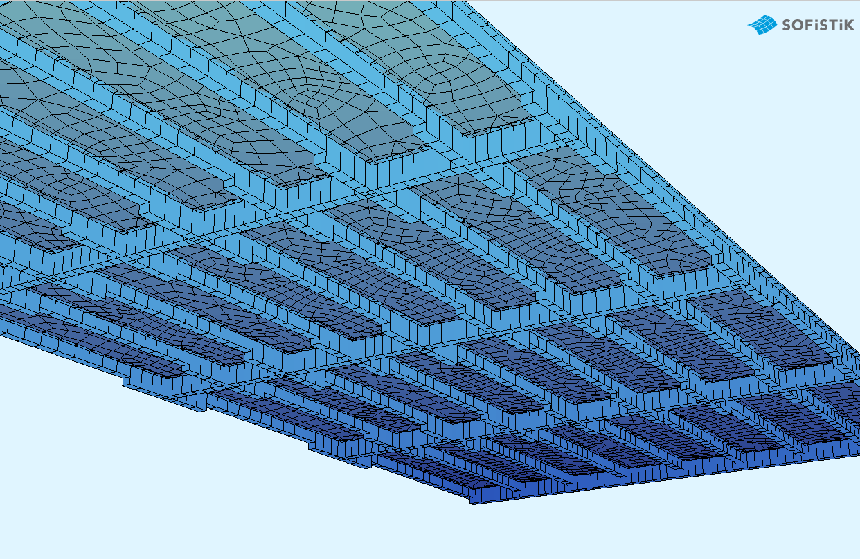

Figure A1 - Design model of flooring showing girder stiffness

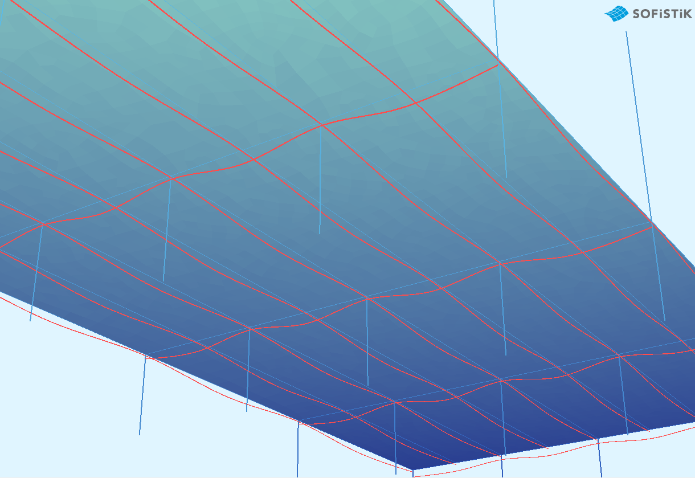

Figure A2 - Arrangement of prestressed reinforcement in the design model